Overview

This tutorial covers how to set up audit trails in Planning.
As an Administrator, you can select aspects of the application for change tracking. You can track changes to metadata, data forms, business rules, workflow, users, and access permissions.
To view audits, you create and run reports by using RDBMS report writers.

Scenario

As Administrator, you have been asked to turn on data and offline change tracking for your Planning application. After setting up change tracking, you need to verify data changes in the HSP_AUDIT_RECORDS table in SQL Server.

Prerequisites

Before starting this tutorial, you should:
1. | Have Administrator rights to Planning applications.
2. | Have access to Workspace and Planning.
3. | Have Administrator access to Microsoft SQL Server Enterprise Manager.

Setting Up Change Tracking

You can enable auditing for dimension administration, alias table administration, data modification, launching business rules, data form definition, data form folder administration, workflow, copy versions, security, user administration, group administration, and offline access.
In this topic, you set up change tracking for data modification and offline access.
To set up change tracking:
1. | Launch Workspace and log on as Administrator.  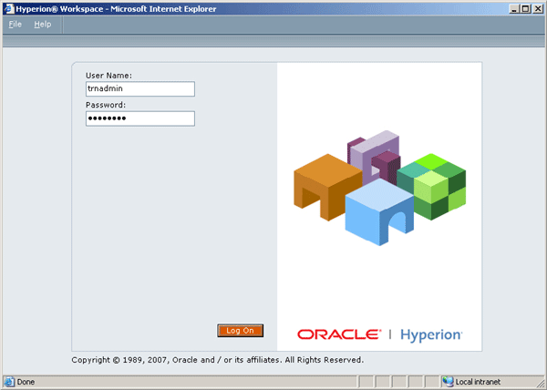
2. | Select Navigate > Applications > Planning > <Planning Application>.  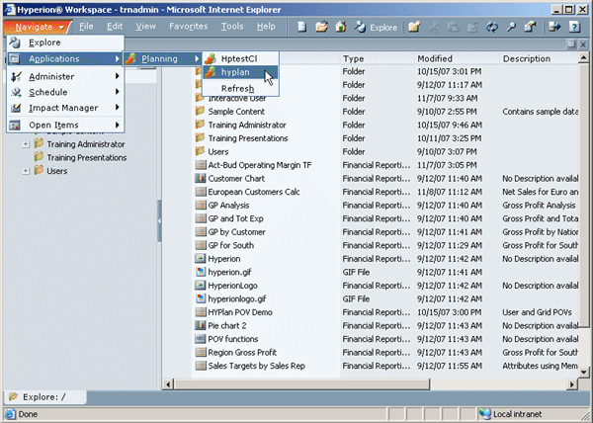
3. | In Planning, select Administration > Reporting.  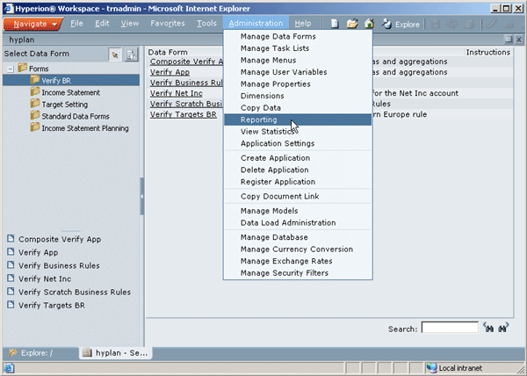
4. | Select the Auditing tab.  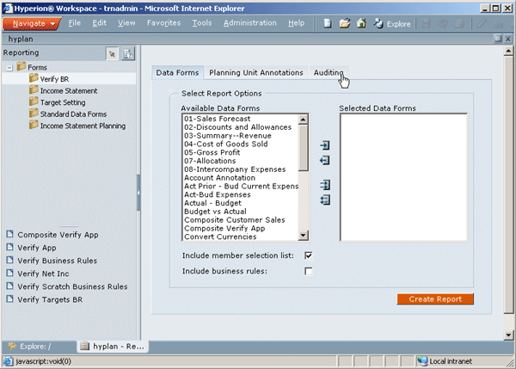
5. | Select the Data and Offline check boxes, and click Save Selections.  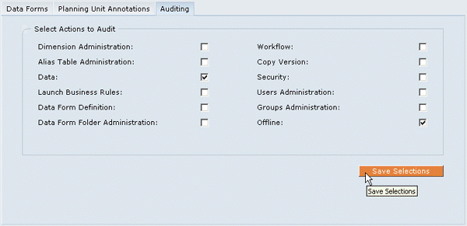
6. | Click Close .  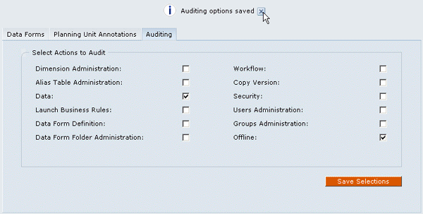
7. | In the view pane, expand Forms. Under Forms, click a folder name to display its content, and click a data form.  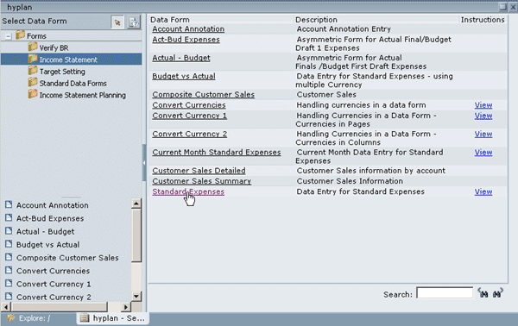
8. | Click an unlocked cell, enter data, and click Save .  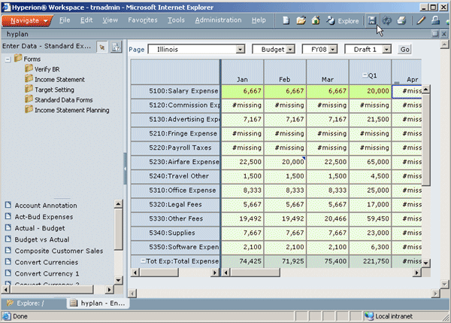

Viewing and Clearing Audit Reports in SQL Server
Depending on selected audit options, application changes are recorded in a HSP_AUDIT_RECORDS table, stored in the relational database. When using SQL Server, you can view and clear audit reports in Enterprise Manager.
To view and clear audit reports in SQL Server:
1. | Open Microsoft SQL Server - Enterprise Manager. From the Console Root, expand Microsoft SQL Servers >SQL Server Group > < SQL Server e.g. local> > Databases > < Planning application database > > Tables.  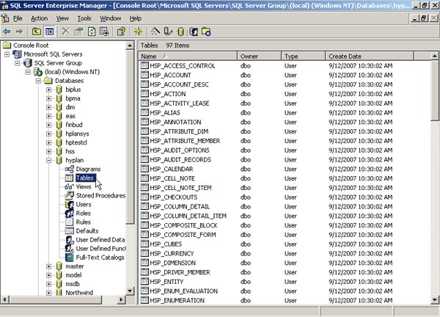
2. | Select the HSP_AUDIT_RECORDS table.  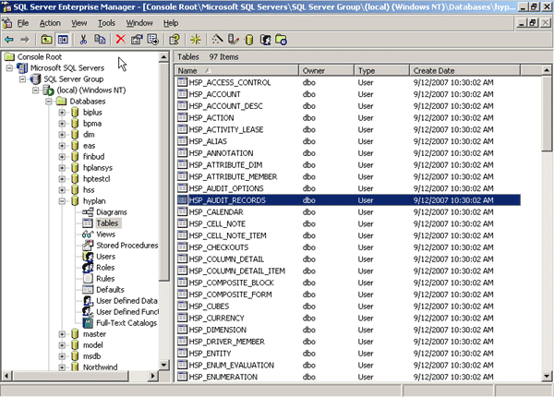
3. | Right-click HSP_AUDIT_RECORDS and select Open Table > Return all rows.  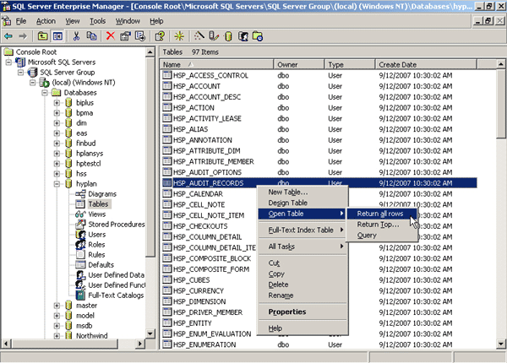
4. | Review the latest records, and click Close .  In this example, data changes applied to all affected cells were posted to the table.  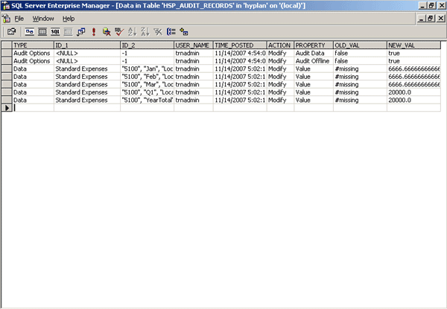
5. | Right-click HSP_AUDIT_RECORDS and select Open Table > Query.  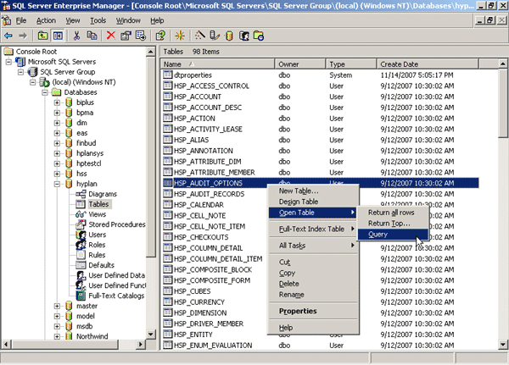
6. | Right-click SELECT, and select Change Type > Delete.  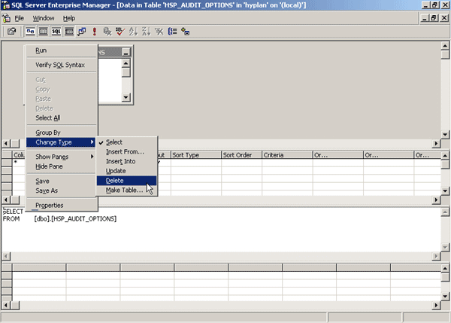
7. | Click Run.  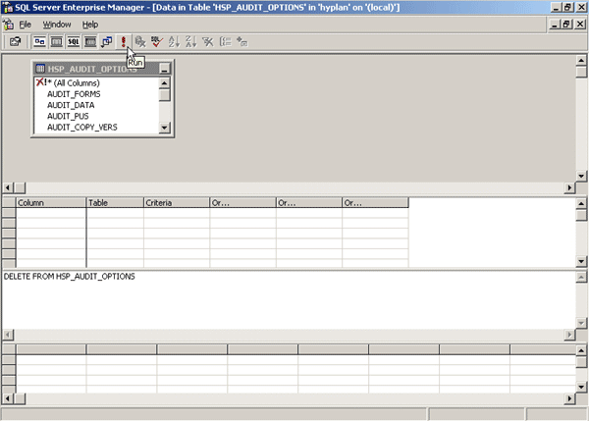
8. | When prompted that the query was executed successfully, click OK.  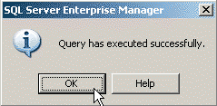
9. | Click Close .  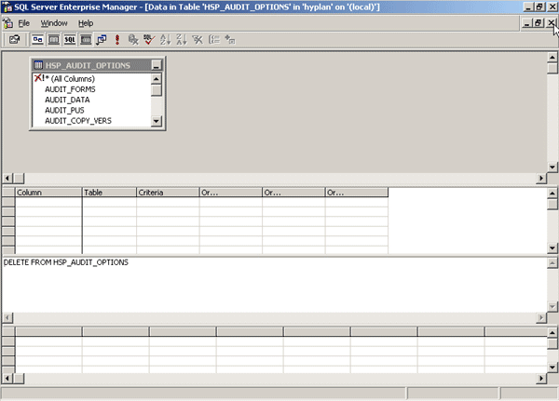
10. | Right-click HSP_AUDIT_RECORDS and select Open Table > Return all rows.
11. | Verify that all records were deleted .

Summary

In this tutorial, you learned how to:
Set up change tracking
View and clear audit reports in SQL Server

